uTMAX 1.0a

Contents

1) Introduction 2

2) Installation 3

Windows 3

Linux 3

3) Calibration 4

4) Data file 7

5) Using The GUI 8

Graph Line Colors 9

Tube Settings & Pinout 9

PLOT Settings 10

Utilities Menu 10

Save Plot Dialog 10

Options Dialog 11

Communications Debug Dialog 12

6) Release Notes 12

7) Known bugs 12

8) Future Work 12

9) uTmax hardware changes for 400mA and -57V 13

## Introduction

|  |  |
| --- | --- |
| **This is an alternative user interface for the uTracer. For the previous generation of this GUI ‘uTgui’, the motivation for this was to add these features**   * Easier to set up * Improve the plot appearance * Add plot save file formats * Directly generate optimized SPICE models * Add a screen current SPICE model * Reduce the frequency of hangs * Provide a data base of valve pin outs and data capture settings to make set up faster * Have open source code * Support multiple platforms   **The following have been added for this generation, uTMax**   * Support for 400V, 400mA and grid one -57V ranges. Note that these require hardware changes. * Auto file save and numbering * Use Derk Reefman’s SPICE models * Easier modification of the tube(valve) database file. * Support dual triodes and diodes. * Allow and save multiple plot windows * Make the GUI window smaller * Quick Test * LCD Panel for quick test display |  |

## Installation

### Windows

Unzip uTMax_bin.zip into a user folder of your choice. Avoid using system folders as read/write access to the data.csv and cal.txt file is required. Run uTmax.exe to execute. You can create a shortcut and add to your Start menu, if you wish.

C:\Users\Nick\AppData\Local\Microsoft\Windows\Temporary Internet Files\Content.IE5\XBRVYQWF\MC900389278[1].wmfThe cal.txt and data.csv file formats are different. You cannot use those generated with uTgui. The tube data.csv file now includes quick test parameters and a new means of identifying the SPICE model. The file extension is now ‘csv’ making somewhat more spreadsheet friendly.

The cal.txt (calibration data file) and data.csv (tube date file) will be overwritten. If you wish to retain your old files, save them first and then overwrite the new ones.

### Linux

utMax uses the QT5.4 shared libraries. You will have to install these prior to utMax by downloading and installing the QT 5.4 community edition http://www.qt.io/qt5-4/.

Next, extract uTmax.tar.gz into your home directory. This will create a uTmax directory containing the executable. You can execute ./utMaxfrom here. Note that debug info will be written to the console. You can avoid this by using the command ./uTgui 2:>/dev/null .

## Calibration

The first step in the calibration procedure is to adjust some settings in calibration file to match your uTracer hardware version. Use a plain text editor such as notepad or gedit to open the cal.txt file and locate and edit the following lines.

|  |  |
| --- | --- |
| RaVal=4700 | Set RaVal to the value of the lower resistor in the voltage sense divider resistors R32 and R18 for your uTracer. The value is usually 6800 for uTracer 3, or 5230 for uTracer 3+. |
| VaMax=400 | Set VaMax to the voltage range of your uTracer i.e. 300 for uTracer 3, or 40 for uTracer 3+. |
| IaMax=400 | Set IaMax to the current range of your uTracer i.e. 200 for uTracer 3 and uTracer 3+ or 400 for the unofficial uTmax hardware version. |
| IsMax=400 | Set IsMax to the same as IaMax |
| VgMax=60 | Set VgMax to the maximum grid voltage of your uTracer i.e. 50 for uTracer 3 and uTracer 3+ or 60 for uTmax hardware version. |

Next, we can perform the calibration proper.

|  |  |  |
| --- | --- | --- |
| Range Check  Start uTmax and check that the values displayed under uTracer range correspond to your hardware. If these are not correct exit and check the settings in the cal.txt file. |  | |
| COM port  Select the desired COM port using the COM pull down select box in the debug/Communication dialog window (Utilities -> Debug).  You can test communications using the ‘Ping’ button.  Hit ‘OK’ |  | |
| **Adjust the supply voltage reading.**  Open the ‘Debug’ and ‘Calibration’ dialog boxes.  Measure the supply voltage at the screw terminals.  Adjust the ‘Vsupply’ slider to indicate the measured value in the ‘Vpwr Value box’ .  You will need to hit the ‘ping’ button whilst doing this to update the Vpwr boxes. |  | |
| **Adjust the negative supply Voltage reading.**  Measure the voltage between the ground on the supply screw terminal and the anode of D1.  Adjust the ‘Vn slider to indicate the measured value in the ‘Vneg Value box’ .  You will need to hit the ‘ping’ button whilst doing this to update the Vneg boxes. |  | |
| **Anode Supply**  First set the delay to ‘10’ in the ‘Option’ dialog box.  Connect a voltmeter between the cathode and positive end of the anode supply capacitor C18. Set the parameters using either 300 or 400 for Start and End according to your cal.txt Va settings:  Press “Start” three times and adjust the Va slider to read 300V on the meter.  Repeat as necessary to set the slider correctly. |  | |
| **Grid 2 Supply**  Similarly for the grid 2 supply by connecting the positive end of the volt meter to the positive end of C13 and use the “Vs” slider. | | |
| **Ia Anode current reading**  Connect a 10k ohm 1% resistor between the anode and cathode terminals. Monitor the Ia current value using the debug / communication dialog. Follow the procedure for Va above using the Ia slider instead. Adjust for a reading of VStart/10 mA i.e. 30 or 40mA. | | |
| **Is Grid 2 current reading**  Connect a 10k ohm 1% resistor between the anode and cathode terminals. Monitor the Is current value using the debug/communication dialog. Follow the procedure for Va above using the Is slider instead. | | |
| **Grid Voltage:**  Connect the meter between the grid and cathode terminals.  Set the parameters for a grid voltage of 0.9V  Pressing “start“ as before, adjust the Vg1 slider to indicate 0.9v.  Repeat using 3.9V and the Vg4 slider.  Repeat using 39.9v and the Vg40 slider. | |  |

## Data file

The data file “data.csv” is a comma-separated-values format file that contains information about the valve settings and pin outs. There is a line per valve type. The top line is always a header that defines the field for each valve description line. This file may be edited as a spreadsheet as required provided the arrangement of the fields or the format is not altered. Use a plain text editor or spreadsheet program.  *However such editing can be done most easily done directly from the GUI.*

## Using The GUI

1. *Quick Guide*

If you hover over any item on the UI, a pop up description of its function will appear.

Most times, simply specify the sweep parameters you want, press “START” and wait. The heater voltage will ramp up and the sweep will start automatically forty-five seconds after maximum heater voltage is reached. The default plot is Ia vs Va. Note that a “step” parameter of zero will apply only the “start” value for that Va, Vs or Vg variable. At the end of the sweep the heater will be turned off to protect the uTracer. At least five data points are required to calculate a model for a triode and six for a pentode.

1. *The UI features*

Specify the sequence number. Auto incrementing

Specify the file name prefix

Specify the plot file format

Enable auto file saving.

Display a Plot tab

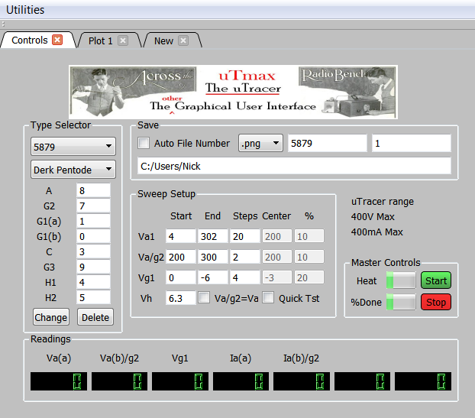

Sets the sweep voltage ranges

Linearized tube parameters are displayed here

Start the measurement sequence

Abort the measurement

Specify file save folder.

Delete selected type from database.

Add a new tube or change the select type in the database. selected tube in the

Displays the pin number for the specified electrode

Associate SPICE model with selected tube

Pick a tube from the database

Select tabs to view control panel or plots

|  |  |
| --- | --- |
|  | Graph Line Colors Clicking on a graph line brings up a color selection tool to allow the color to be customized.  The user color preferences are saved to the “cal.txt” file.  A color definition line in the “cal.txt” file looks like this:  PenNRGBWS=0,240,51,51,2  The numbers are respectively:  Graph line number  Red value 0-255  Green value 0-255  Blue value 0-255  Line width 1-3  If a plot is generated which has more lines that are defined, then the table is extended and existing colors are reused. |
|  | Tube Settings & Pinout The Model selector pulls pin out information and default parameters from the data.txt file. Its use is not required but it does save time.  The “Type” selector is used by the SPICE model generator. Click here for more information <http://dos4ever.com/uTracer3/uTracer3.html>  After completing a measurement sequence, the selected SPICE model parameters are computed. If you selected a different model, the parameters for that model are recalculated. You can assess the quality of the fit by examining the plots.  For dual diodes and triodes, the Vg2 supply is used for the anode of the (b) section.  C:\Users\Nick\AppData\Local\Microsoft\Windows\Temporary Internet Files\Content.IE5\XBRVYQWF\MC900389278[1].wmfNote the measurement sequence is affected by the choice of SPICE model. For DIODE only a Va sweep is performed. For TRIODES Va=Vg2 and Vg2. Va is used for the A section and Vg2 is used for the B section ( if it exists). F=For PENTODES and BEAM TETRODES a triode sweep is performed first and then the Va, Vg2 and Vg sweep are done. |
|  | PLOT Settings **X, Y1, Y2 Axis Controls**  The plot may be changed by use of the drop down axis control lists “X=”, “Y1=” and “Y2=” at any time. IaMod and IsMod are the currents determined by the internal optimized SPICE device model.  **Plot Legend**  This check box adds a legend to the plot. This list can get very long if you use a big data set. |
|  | Utilities Menu The “Utilities” menu provides access to functions for saving plots, data and spice models, also access to less frequently used features viz, calibration and debug dialogs.  ‘Read Data’ loads a previously saved data set and plots the data. The SPICE model is recalculated. This allows old data sets to be used to create the model parameters using the latest version of SPICE device models. |
|  | Save Plot Dialog The format of the file is specified by typing the three letter file extension for the desired (and supported) type. |
|  | Options Dialog Less frequently used features like current limiting can be found in the “Options” dialog.  **Ia Range**  Sets the uTracer ADC range in mA used for anode current measurement  **Is Range**  Sets the uTracer ADC range in mA used for screen current measurement.  **Averaging**  Specifies how many samples are taken for each measurement.  **Limit mA**  Specified the current above which the uTracer will shut down the high voltage supply for that measurement. If the check box is checked, the measurement sequence is aborted when the current limit is exceeded.  **Delay**  Specifies the time in seconds between measurements |
|  | Communications Debug Dialog **Va / Vs / Vg / Vh**  Displays the requested values for these parameters in the command string in hexadecimal, decimal and human readable values.  **ADC Reading**  Displays the measured values from the ADC in the uTracer. These are updated on pressing the “**Read ADC”** button  **“Ping” Button**  This sends the “no-op” command ““300000000000000000” to the uTracer. If the command is echoed the command will be seen in the “Rx” box and the message “Ping OK” will be seen momentarily on the status line (on the main window). |

## Release Notes

Changed / fixed in release 1-0

Initial release 1.0a

## Known bugs

The UI cannot overcome cases where the firmware hangs. The only option is to exit the GUI, power cycle the uTracer and restart.

If the UI is open and the PC goes into suspend, then subsequent use of the serial port may crash the computer. This is likely a problem with the USB driver used in testing.

There must be at least two com ports in the system.

## Future Work

None planned

## uTmax hardware changes for 400mA and -57V

1. 400mA supplies. This is accomplished by adding a second HV switch transistor to each of the Anode and Screen supplies and changing the current sense resistor from 18 ohms to 9.1 ohms 1% 2 watt
   1. 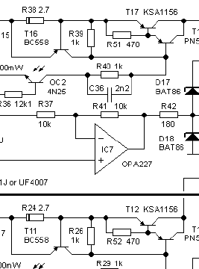For the anode supply, connect a KSA1156 transistor , call it “T17A” as follows
      1. T17A collector to T17 collector
      2. T17A base to T17 base
      3. T17A emitter to one end of a new 2.7 ohm 0.5W resistor
      4. Connector the other end of the new 2.7 ohm resistor to the emitter of T16
      5. Change R45 to 9.1 ohms 2 watt
   2. For the screen supply, the changes are similar to the anode supply but use T12 and T11 and change R20
2. 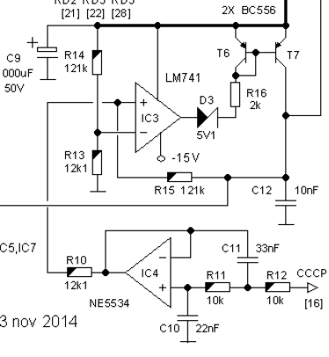Grid one supply range (-57V)
   1. Change R14 and R15 to 1M ohm
   2. Change R13 and R10 to 121K ohm
   3. Add a 63V 10pF ceramic capacitor across R15
   4. Change IC3 to a TL071

**Parts list**

2 x 121K 0.25W 1% resistors

2 x 1M 0.25W 1% resistors

1 x 10pF 63V ceramic capacitor

2 x KSA1156 transistors

2 x 9.1 ohm 1% 2W resistors

2 x 2.7 ohm 1% 1W resistors